**Project Planning Phase**

**Project Planning Template (Product Backlog, Sprint Planning, Stories, Story points)**

|  |  |
| --- | --- |
| Date | 18 November 2022 |
| Team ID | PNT2022TMID39001 |
| Project Name | Project - AI-Powered Nutrition Analyzer for Fitness Enthusiasts |
| Maximum Marks | 8 Marks |

**Product Backlog, Sprint Schedule, and Estimation (4 Marks)**

Use the below template to create product backlog and sprint schedule

|  |  |  |  |  |  |  |
| --- | --- | --- | --- | --- | --- | --- |
| **Sprint** | **Functional**  **Requirement**  **(Epic)** | **User Story**  **Number** | **User Story / Task** | **Story Points** | **Priority** | **Team Members** |
| Sprint-1 | Registration | USN-1 | As a user, First I have to register for IBM cloud | 2 | High | Logeswari Jayasri Gnanavizhi  Praveenkumar |
| Sprint-1 | Collecting the datasets | USN-2 | As a user, I have to collect and download the datasets | 2 | High | Logeswari Jayasri Gnanavizhi |
| Sprint-1 | Image  Preprocessing | USN-3 | After collecting the datasets,Image Preprocessing has to be done. | 2 | Medium | Logeswari Gnanavizhi |
| Sprint-2 | Model building | USN-4 | After image preprocessing, user has to build the model | 2 | High | Praveenkumar Jayasri |
| Sprint-2 |  | USN-5 | As a user, I have to develop a code for this model building and I have to build a model | 2 | High | Jayasri Gnanavizhi |
| Sprint-3 | Application building | USN-6 | After model building,I have to create an application for the end users | 2 | High | Logeswari Jayasri Gnanavizhi  Praveenkumar |
| Sprint-3 |  | USN-7 | As a user, I have to Create a folder which contains all the necessary html, css,js and python coding files | 1 | Medium | Jayasri Gnanavizhi Logeswari  Praveenkumar |
| **Sprint** | **Functional**  **Requirement (Epic)** | **User Story**  **Number** | **User Story / Task** | **Story Points** | **Priority** | **Team Members** |
| Sprint-3 |  | USN-8 | I have to create a folder name flask,where I have to paste all the above mentioned coding files in that folder | 2 | High | Logeswari Gnanavizhi Jayasri  praveenkumar |
| Sprint-4 | Outputs | USN-9 | Link the flask file with html files and I have to share the screenshots of the output webpage | 2 | High | Praveenkumar Jayasri Gnanavizhi Logeswari |
| Sprint-4 |  | USN-10 | As a user, I have to deploy the model on IBM | 2 | High | Praveenkumar Logeswari Jayasri Gnanavizhi |

**Project Tracker, Velocity & Burndown Chart: (4 Marks)**

|  |  |  |  |  |  |  |
| --- | --- | --- | --- | --- | --- | --- |
| **Sprint** | **Total Story Points** | **Duration** | **Sprint Start Date** | **Sprint End Date (Planned)** | **Story Points**  **Completed (as on**  **Planned End Date)** | **Sprint Release Date (Actual)** |
| Sprint-1 | 20 | 6 Days | 24 Oct 2022 | 29 Oct 2022 | 20 | 29 Oct 2022 |
| Sprint-2 | 20 | 6 Days | 31 Oct 2022 | 05 Nov 2022 | 20 (In-process) | 05 Nov 2022 |
| Sprint-3 | 20 | 6 Days | 07 Nov 2022 | 12 Nov 2022 | 20(In-process) | 12 Nov 2022 |
| Sprint-4 | 20 | 6 Days | 14 Nov 2022 | 19 Nov 2022 | 20(In-process) | 19 Nov 2022 |
|  |  |  |  |  |  |  |
| **Sprint** | **Total Story Points** | **Duration** | **Sprint Start Date** | **Sprint End Date (Planned)** | **Story Points**  **Completed (as on**  **Planned End Date)** | **Sprint Release Date (Actual)** |
|  |  |  |  |  |  |  |
|  |  |  |  |  |  |  |
|  |  |  |  |  |  |  |

**Velocity:**

Imagine we have a 10-day sprint duration, and the velocity of the team is 20 (points per sprint). Let’s calculate the team’s average velocity (AV) per iteration unit (story points per day)

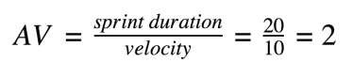

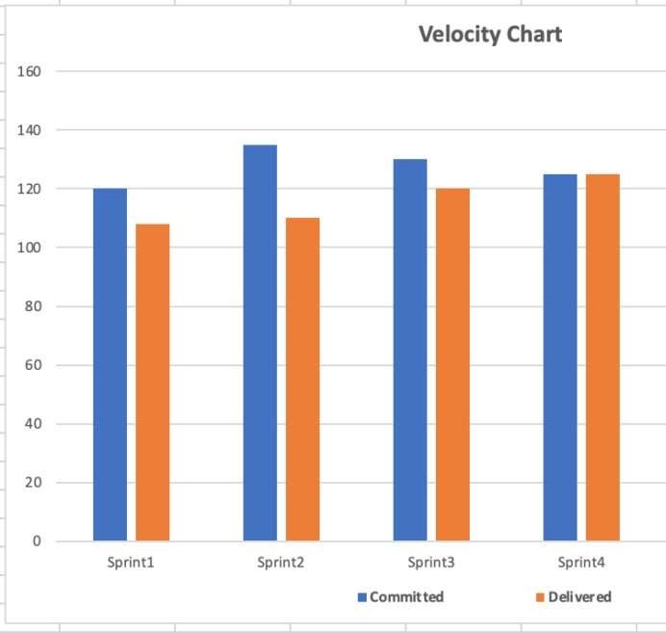

**Burndown Chart:**

A burn down chart is a graphical representation of work left to do versus time. It is often used in agile [software development m](https://www.visual-paradigm.com/scrum/what-is-agile-software-development/)ethodologies such as [Scrum.](https://www.visual-paradigm.com/scrum/scrum-in-3-minutes/) However, burn down charts can be applied to any project containing measurable progress over time.

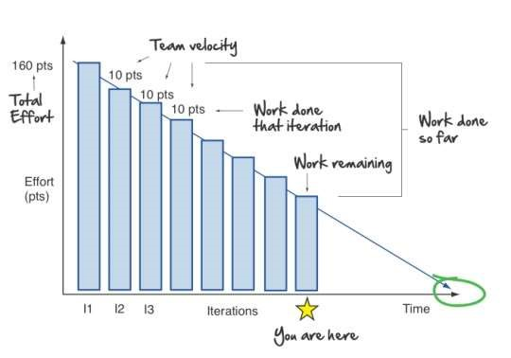



[**https://www.visu**](https://www.visual-paradigm.com/scrum/scrum-burndown-chart/)

[**a**](https://www.visual-paradigm.com/scrum/scrum-burndown-chart/)



[**l**](https://www.visual-paradigm.com/scrum/scrum-burndown-chart/)



[**-**](https://www.visual-paradigm.com/scrum/scrum-burndown-chart/)



[**p**](https://www.visual-paradigm.com/scrum/scrum-burndown-chart/)

[**u**](https://www.visual-paradigm.com/scrum/scrum-burndown-chart/)

[**aradigm.com/scrum/scr**](https://www.visual-paradigm.com/scrum/scrum-burndown-chart/)



[**m**](https://www.visual-paradigm.com/scrum/scrum-burndown-chart/)



[**-**](https://www.visual-paradigm.com/scrum/scrum-burndown-chart/)



[**o**](https://www.visual-paradigm.com/scrum/scrum-burndown-chart/)

[**urnd**](https://www.visual-paradigm.com/scrum/scrum-burndown-chart/)

[**b**](https://www.visual-paradigm.com/scrum/scrum-burndown-chart/)



[**w**](https://www.visual-paradigm.com/scrum/scrum-burndown-chart/)



[**n**](https://www.visual-paradigm.com/scrum/scrum-burndown-chart/)



[**-**](https://www.visual-paradigm.com/scrum/scrum-burndown-chart/)



[**c**](https://www.visual-paradigm.com/scrum/scrum-burndown-chart/)

[**har**](https://www.visual-paradigm.com/scrum/scrum-burndown-chart/)

[**t**](https://www.visual-paradigm.com/scrum/scrum-burndown-chart/)



[**/**](https://www.visual-paradigm.com/scrum/scrum-burndown-chart/)



[**https://www.atlassian.com/agile/tutorials/burndo**](https://www.atlassian.com/agile/tutorials/burndown-charts)

[**w**](https://www.atlassian.com/agile/tutorials/burndown-charts)



[**n**](https://www.atlassian.com/agile/tutorials/burndown-charts)



[**-**](https://www.atlassian.com/agile/tutorials/burndown-charts)



[**c**](https://www.atlassian.com/agile/tutorials/burndown-charts)

[**har**](https://www.atlassian.com/agile/tutorials/burndown-charts)

[**t**](https://www.atlassian.com/agile/tutorials/burndown-charts)



[**s**](https://www.atlassian.com/agile/tutorials/burndown-charts)



**Reference:**



|  |  |  |  |  |  |  |  |  |
| --- | --- | --- | --- | --- | --- | --- | --- | --- |
| [**https://www.atlassian.com/agile/project**](https://www.atlassian.com/agile/project-management) | [**-m** **anagemen**](https://www.atlassian.com/agile/project-management) | | | [**t**](https://www.atlassian.com/agile/project-management)  [**scrum** **-**](https://www.atlassian.com/agile/tutorials/how-to-do-scrum-with-jira-software) | [**w** **it** **h-**](https://www.atlassian.com/agile/tutorials/how-to-do-scrum-with-jira-software) | [**j** **ira** **-**](https://www.atlassian.com/agile/tutorials/how-to-do-scrum-with-jira-software) | [**s** **oftware**](https://www.atlassian.com/agile/tutorials/how-to-do-scrum-with-jira-software) |  |
| [**https://www.atlassian.com/agile/tutorial**](https://www.atlassian.com/agile/tutorials/how-to-do-scrum-with-jira-software) | [**s/how** **-**](https://www.atlassian.com/agile/tutorials/how-to-do-scrum-with-jira-software) | [**to** **-**](https://www.atlassian.com/agile/tutorials/how-to-do-scrum-with-jira-software) | [**d** **o** **-**](https://www.atlassian.com/agile/tutorials/how-to-do-scrum-with-jira-software) |
| [**https://www.atlassian.com/agile/tutorial**](https://www.atlassian.com/agile/tutorials/epics) | [**s/epics**](https://www.atlassian.com/agile/tutorials/epics) | [**t** **s**](https://www.atlassian.com/agile/tutorials/sprints) | |  | [**matio** **n**](https://www.atlassian.com/agile/project-management/estimation) |  | |
| [**https://www.atlassian.com/agile/tutorial**](https://www.atlassian.com/agile/tutorials/sprints) | [**s/sprin**](https://www.atlassian.com/agile/tutorials/sprints) |
| [**https://www.atlassian.com/agile/project**](https://www.atlassian.com/agile/project-management/estimation) | [**-m** **anagement/esti**](https://www.atlassian.com/agile/project-management/estimation) | | |
| [**https://www.atlassian.com/agile/tutorials/burndown** **-**](https://www.atlassian.com/agile/tutorials/burndown-charts) | | | | [**charts**](https://www.atlassian.com/agile/tutorials/burndown-charts) |  |